**Foundations of Data Science**

CS-GY 6053

Hate Crime Analysis and Forecasting

*Revati Trivedi (rst8739)*

*Yamini Narasimhan (yl9822)*

*Pranjal Jain (pj2069)*

*What is the problem (including motivation and what is the specific outcome)?*

**Motivation**

Hate Crime is a crime motivated by a victim’s race, ethnicity, sexual orientation, color, national origin, gender identity, or disability. With the rising amount of Hate Crimes, it is crucial to analyze and understand the trends of Hate crimes to increase awareness and promote a more inclusive and healthy environment.

The goal of this project is to analyze historical data on hate crimes and forecast the number of hate crimes in the future.

*What kinds of data will you use? (describe the data fully including its temporal and spatial dimensions, features, and their types and scales (e.g. numerical or text, ordinal or nominal, etc.))*

## Source of dataset

| **Feature Name** | **Data Type** | **Description** | **Cleaning Procedure** |
| --- | --- | --- | --- |
| incident_id: | Numerical, Nominal | Unique ID for Incident | Drop |
| data_year | DATE | Year of incident |  |
| ori: | Text-Nominal | Code | Drop |
| pub_agency_name | Text-Nominal | Agency that reported |  |
| pub_agency_unit | Text-Nominal | Agency Unit | Drop |
| agency_type_name | Text- Ordinal | Type of Agency reported | Drop |
| state_abbr | Text -Nominal | State Name Abbreviated |  |
| state_name | Text -Nominal | State Name | Drop |
| division_name | Text -Nominal | Division area | Drop |
| region_name | Text -Nominal | Region Name | Drop |
| population_group_code | AlphaNum -Ordinal | Population of location-Coded | One hot Encoding and Standardize as using from multiple agencies |
| population_group_desc | Text -Ordinal | Population of location | Drop |
| incident_date | DATE | Exact Date of Incident | Standardize Date format |
| adult_victim_count | Numerical | Count of Adult Victims | Drop |
| juvenile_victim_count | Numerical | Count of juvenile Victims | Drop |
| total_offender_count | Numerical | Total Count of all Offenders | Drop |
| adult_offender_count | Numerical | Count of Adult Offenders | Drop |
| juvenile_offender_count | Numerical | Count of juvenile Offenders | Drop |
| offender_race | Text -Nominal | Offender’s Race | Drop: Irrelevant |
| offender_ethnicity | Text -Nominal | Offender’s ethnicity | Drop: Irrelevant |
| victim_count | Numerical | Count of all Victims |  |
| offense_name | Text -Nominal | Type of Offense | Standardize |
| total_individual_victims | Numerical | Count of all Victims |  |
| location_name | Text - Ordinal | Type of Place incident Occured |  |
| bias_desc | Text - Ordinal | Type of ethnicity Targeted |  |
| victim_types | Text - Ordinal | Victim Type |  |
| multiple_offense | Text - Ordinal | Single or Multiple offense |  |
| multiple_bias | Text - Ordinal | Single or Multiple Bias |  |

**Dimension**: 219,578 X 28

**Time range:** 1991- 2020

## **Observations and insights into outliers**:

Highest Committed Offense Type is Intimidation and Vandalism

Highest Committed Offense Location is Residential/Home

In 2020 there was a peak in hate crimes against Asians and in 2001 an increase in hate crimes against Muslims and Arab Immigrants.

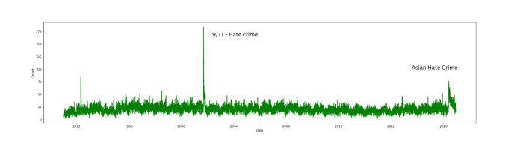

*For further details please refer code

**Methodology**

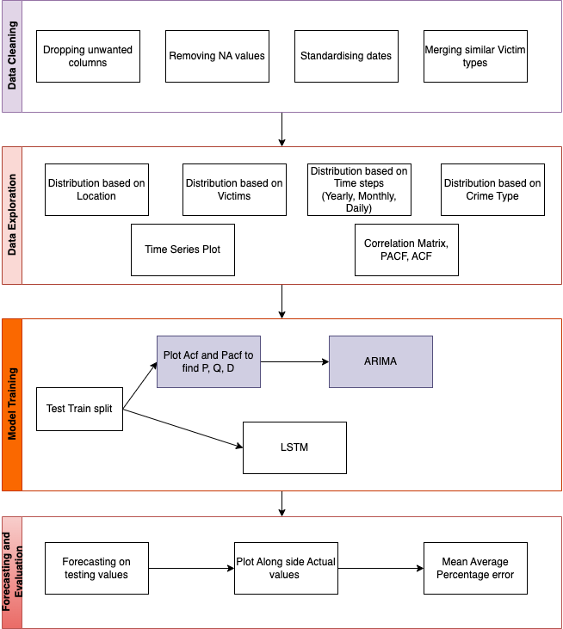

We are trying to predict the count of hate crime incidents for a month for the forecasting horizon of 6 months (refer to the evaluation section for the accuracy of each horizon). We are using all years after 1991 and before 2017 as we can see seasonality for all years.

Since the dataset is collected by multiple agencies and aggregated by the FBI, we had to update and merge values for a few columns.

**About the data**

We are using the data provided on the FBI site - <https://crime-data-explorer.app.cloud.gov/pages/explorer/crime/hate-crime>.

This data is being collected per the Hate Crime Statistics Act passed on April 23, 1990. It also has extensive documentation defining each type of violation and its specific conditions. It also discusses the method of collection, the data points collected, and what is included. It includes 200,000 data points of incidents, each giving attributes of the hate crime like offender race, victim race, location, and more.

The website <https://www.fbi.gov/how-we-can-help-you/need-an-fbi-service-or-more-information/ucr/hate-crime> is a great source of information for learning more about the dataset and about Hate Crime in general.

## **Data Cleaning Process:**

We first dropped the irrelevant columns like population attribute description, juvenile_offender_count, and more (refer to the table). We subsequently merged many different values into a standard convention (performed on victim race, Anti Bisexual -> Anti Queer, as they have the same definition and also can be characterized as a hate crime against the LGBT community). We also standardized the dates. We split multiple offenses into multiple single offenses each with different values. We also standardized the population code as multiple agencies use different conventions.

We also formed a new dataset on which we perform forecasting using the count of hate crimes per month for months from 1992 to 2017.

*What kind of model will you build? (What approach will you take for solving the problem and why not any other approaches, including how data will be cleaned, what specific algorithm(s) and any parameters used, and how you will evaluate your approach – describe a figure/table used to illustrate the evaluation)*

**Model**

We focused and shortlisted two models to forecast hate crime using our cleaned dataset.

## **ARIMA or AutoRegressive Integrated Moving Average:**

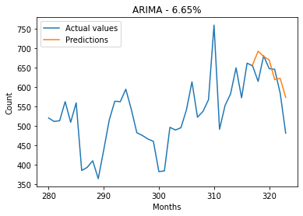

Arima performs exceptionally on time series forecasting and we also found great results. While using ARIMA we initially theorized the value of P,D,Q as 5,2,2 from the ACF and PACF plots, but found using different parameters that 7,3,1 was showing a much better fit and was able to capture the trends of the data

## **LSTM or Long short-term memory**

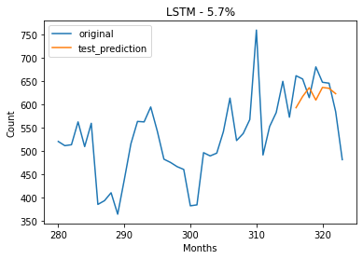

We found that ARIMA was plateauing after a certain forecasting horizon, so we utilized a deep learning model to get better predictions. LSTM was accurate and was able to capture the trends.

**Evaluation**

| **Model** | **6 months** | **18 months** | **24 months** |
| --- | --- | --- | --- |
| ARIMA | 6.65% | 16.38% | 16.63% |
| LSTM | 5.7% | 7.74% | 10.8% |

We forecasted on different horizons and found that the Mean Average Percentage error is as given in the table above for each of the forecasting horizons, in both the models. For ARIMA and LSTM we saw similar accuracy for the 6-month forecasting horizon but that quickly increased for ARIMA as the predictions plateaued. ARIMA gave a static value after 9-10 months of predicting in our case. LSTM showed higher accuracy and was able to show trends even 2 years into forecasting, much closer to the actual values.

*What assumptions are safe to make? (Explain clearly what the assumptions being made are and why that’s okay, this could be in terms of features considered, potential confounding variables, variable types, etc.)*

**Assumptions**

All states/agencies across various states participate voluntarily in the submission of Hate Crime reports to the FBI. We assume that the states are reporting most of the hate crimes and there are no duplicate events considered more than once, this is due to unique ID tags for each crime.

**Limitations**

Because the motivation for Hate crime is subjective, it is sometimes difficult to know with certainty whether a crime resulted from the offender’s bias. This creeps into the dataset as it is at the discretion of the investigating officer to classify a crime as a Hate crime. This may result in many hate crimes not making it into the dataset. The data is also not uniformly collected. There are locations where hate crime is not collected, making it difficult to make a general prediction.

We assume that most of the crimes reported have a specific motivation that leads it to be considered as a Hate Crime under how FBI crime explorer categorizes it as a hate crime.

We are dropping some features such as incident_id and population_group_desc due to their irrelevance in predicting the time series of hate crimes. We are also dropping some features such as offender race and ethnicity to avoid bias creeping into the data.

**Future Scope**

The current implementation can serve as an excellent base for creating a forecasting system that can actually predict trends of hate crime and even predict spikes in the dataset which are unrelated to past trends.

We can use other sources such as economic trends, news, or Twitter sentiments and add that as feedback in the LSTM we implement.